MAT 150 Case 3 Assignment and Template

I affirm that this assignment contains all original work. I am familiar with Trident University’s Academic Integrity policy located in the Trident Policy Handbook. I affirm that I have not engaged in direct duplication, copy/pasting, sharing assignments, collaboration with others, contract cheating and/or obtaining answers online, paraphrasing, or submitting/facilitating the submission of prior work. Work found to be unoriginal and in violation of this policy is subject to consequences such as a failing grade on the assignment, a failing grade in the course, and/or elevated academic sanctions. My name below affirms that the assignment was completed individually, and all work presented is my own.

Name:
Date:
Instructor:

Use this template to insert your answers for the assignment. Please use one of the four methods for showing your work (EE, Math Type, ALT keys, or neatly typed). Remember that your work should be clear and legible.

Problems need to include all required steps and answer(s) for full credit. All answers need to be reduced to lowest terms where possible.

1. Is the following relation a function? Why or why not?
{(0, 1); (2, 6); (3, 4); (6, 1)}

Calculations:

Answer: _______________

2. Is the following relation a function? Why or why not?
{(2, 3); (3, 3); (2, 4); (9, 4)}

Calculations:

Answer: _______________

3. Given the function f(x) = 2x - 3, find three ordered pairs on the line.
Calculations:

Answer: _______________

4. When f(x) = x² + 2x - 5, find f(-3), f(0), and f(4).
Calculations:

Answer: _______________

5. Rewrite the equation 5x – 7y = 15 as a function of x.
Calculations:

Answer: _______________

In each of the following graphs, the bolded line represents a mathematical relationship between x and y. Use the vertical line test to determine whether the relationship is a function. Explain the reason for your conclusion.

6. 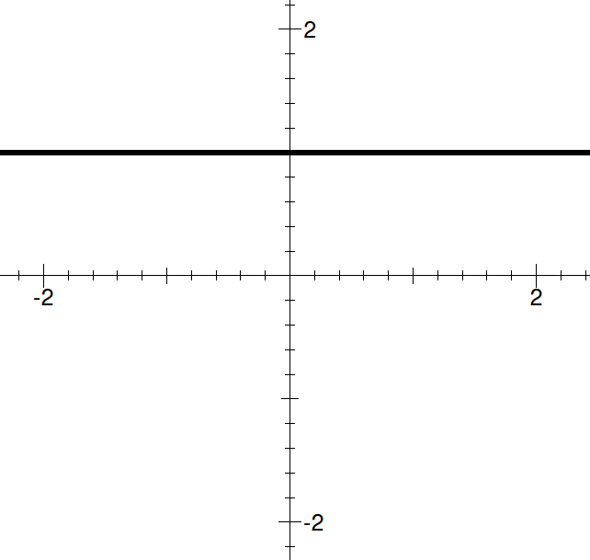 | 7. 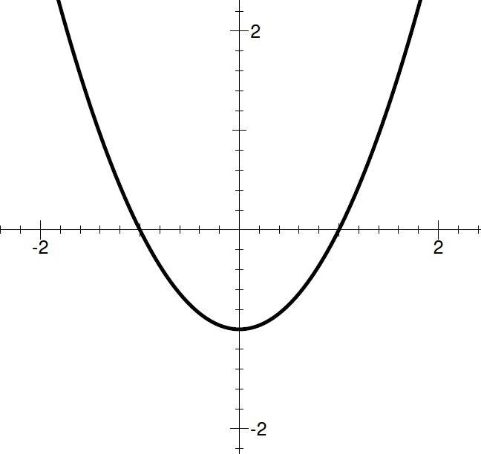
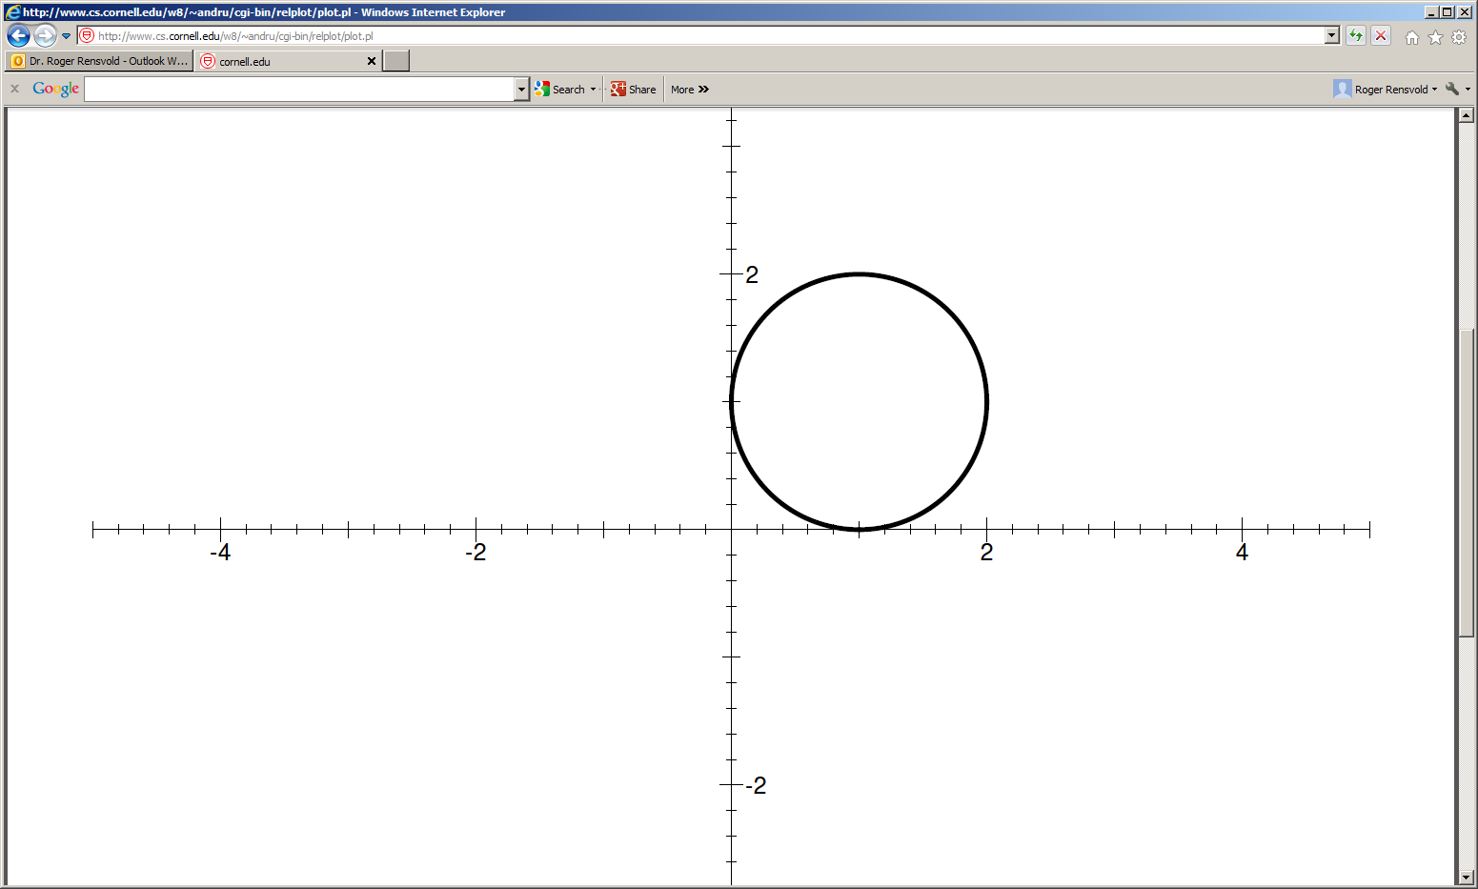  8. | 9. 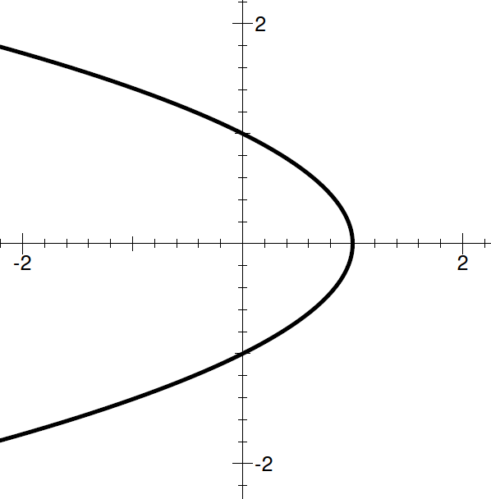

6. Answer: _______________
7. Answer: _______________
8. Answer: _______________
9. Answer: _______________

The graph on the right represents the function .  10. What are the roots of the parabola?  Answer: _______________  11. What is the domain of the function?  Answer: _______________  12. What is the range of the function?  Answer: _______________ | 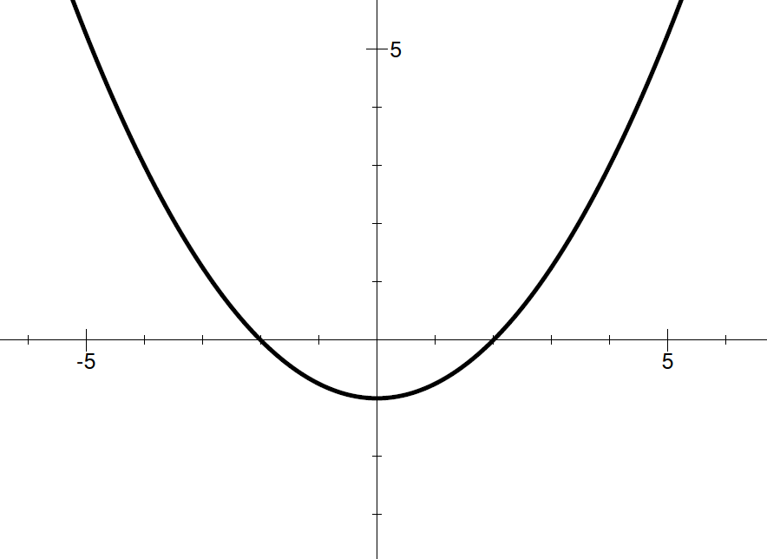

Evaluate the composite functions.

13. If f(x) = x+2 and g(x) = 3x+1, then find (f · g) (2).
Calculations:

Answer: _______________

14. If f(x) = 2x-3 and g(x) = x+3, then find (g · f) (5).
Calculations:

Answer: _______________

15. If f(x) = -5x+7 and g(x) = 3x-5, then find (f - g) (4).
Calculations:

Answer: _______________

